AI-Powered Virtual Assistant for SIBA
FYP Code:29
Software Design Specification

BY:
Muhammad Uzair CMS. ID: 023-22-0235
Mujeebullah CMS. ID: 023-22-0271
Afifa Nazeer CMS. ID: 023-22-0003



Supervised by: Dr Zakira Jamali

____________________
Signature of Supervisor

DEPARTMENT OF COMPUTER SCIENCE
FACULTY OF SCIENCE AND INFORMATION TECHNOLOGY
SUKKUR IBA UNIVERSITY

Document History
Version | Name of Person | Date | Description of change
1.0 | Muhammad Uzair, Mujeebullah, Afifa Nazeer | 30-10-25 | Draft1
1.1 | Dr Zakira Jamali | 31-10-25 | Review
1.2 | Muhammad Uzair, Mujeebullah, Afifa Nazeer | 02-11-25 | Revised

1. Introduction 1
1.1. Purpose of Document 1
1.2. Definitions, acronyms, and abbreviations 1
2. Overall System Description 2
2.1. Project Background 2
2.2. Project Objectives 3
3. System Architecture 4
4. Domain Model 6
5. Class Diagram 7
6. Database Diagram 8
7. Entity Relationship Diagram (ERD) 9
8. Sequence Diagram 10
9. System Interface Design 17
10. Test Cases 23

- Introduction
  - Purpose of Document
The purpose of this document is to define Software Design Specification (SDS) for the AI-Powered Virtual Assistant of SIBA. Its primary purpose is to serve as a comprehensive technical blueprint that guides the development of an intelligent, web-based assistant capable of providing accurate responses to student and faculty queries. This document outlines the system’s architecture, design components, data flow, and interaction between modules to ensure a clear understanding of how the chatbot operates and fulfills its objectives. This document serves as a blueprint for developers, testers, and stakeholders, providing detailed design specifications for implementing key functionalities such as data automation, admin‑based content management, retrieval-augmented generation (RAG), integration of LLMs, the use of MongoDB and VectorDB, authentication, and role-based access control. Overall, this SDS ensures that the system is designed to deliver real-time, personalized, and up-to data information while maintaining scalability, reliability, and security.

  - Definitions, acronyms, and abbreviations

Table 1.1 Abbreviations and Definitions
Acronyms/Abbreviations | Definitions
AI (Artificial Intelligence) | It is capability of a system to simulate human-like reasoning and understanding
RAG (Retrieval-Augmented Generation) | A technique in which relevant information is fetched from knowledge base and sent to LLM to generate response.
LLM (Large Language Model) | An advanced AI model used to process and generate text data.
SST (Speech-to-Text) | A feature which converts voice into text.
TTS (Text-to-Speech) | A feature which converts text into voice

VectorDB | A database is used to store the embeddings of data.
API (Application Interface) | A set rules and protocols that allow communication between different software components.
XML (Extensible Markup Language) | A markup language for structuring like HTML
JSON (JavaScript Object Notation) | A light-weight data-interchange format used for data storage and transfer
DB (Database) | A system which is used for managing and storing data

- Overall System Description
  - Project Background
In Sukkur IBA University, students and faculty members frequently require quick access to a wide range of academic and administrative information, such as course outlines, policies, faculty details, timetables, events, and scholarship opportunities. However, manually searching through university websites can be time-consuming and inefficient. To address these challenges, the AI-Powered Virtual Assistant for SIBA has been conceptualized as an intelligent digital assistant designed to provide instant, accurate, and context-ware responses to user queries.
The system leverages Artificial Intelligence (AI) and Natural Language Preprocessing (NLP) to understand user intent and deliver relevant information in conversational form. It integrates automation mechanisms including email-based data ingestion and information extraction to ensure continuous and reliable updates of university data such as timetables, events, and scholarship information. The chatbot’s architecture incorporates MongoDB for storing structured data and a Vector Database for managing embedded text representations used in Retrieval-Augmented Generation (RAG) responses.
Furthermore, the system supports role-based access control (RBAC) to distinguish between guest and authenticated users with SIBA mail, ensuring data privacy and personalized interactions. With additional features such as Speech-to-Text (STT), Text-to-Speech (TTS), chat history management and sharing capabilities, the project aims to enhance the accessibility and efficiency of university communication systems. Ultimately, this chatbot represents a step towards digital transformation within academic institutions by automating information delivery and improving the overall user experience.

  - Project Objectives
The primary objectives of the project:
- Develop an AI-Chatbot: Create an intelligent chatbot capable of understanding and responding to natural language queries using large language model (LLM).
- Enable Dynamic Data Management: Implement an email-based ingestion and information extraction mechanism to automatically process and update university-related data such as timetables, events, and scholarship information. In addition, provide an admin-based content management interface that allows authorized administrators to add, update, and maintain dynamic institutional content within the system, ensuring data accuracy and consistency.
- Provide Multi-Domain Information: Allow users to retrieve details related to policies, faculty profiles, course outlines, events and scholarship opportunities, ensure comprehensive information coverage.
- Support Role-Based Access Control (RBAC): Restrict and customize chatbot responses based on user roles (guest, student, faculty) to maintain privacy and personalization. Guest can access general information while student, faculty can access all types of information.
- Speech Interaction Capabilities: Integrate Speech-to-Text (STT) and Text-to-Speech features for a hands-free, voice-enabled interaction experience.
- Maintain Chat History and Sharing Options: Store user chat sessions and allow users to share useful conversions for reference or collaboration.

- System Architecture
The AI-Powered Virtual Assistant for SIBA follows a layered client–server architecture with a modular backend design. The system operates as a single backend application while keeping functionalities logically separated to ensure clarity, maintainability, and scalability.

1. Presentation Layer
This layer provides user interaction interfaces:
- Chatbot UI: Allows students and users to interact with the virtual assistant using text or voice.
- Admin Panel: Enables administrators to manage content, users, and system configurations.
Both interfaces communicate with the backend through secure RESTful APIs.

2. Application Layer

This layer contains the core business logic of the system, including:
- Authentication & RBAC (Role-Based Access Control) to manage user permissions
- Query Processing Module to handle user requests
- Admin Content Management Module for updating knowledge and system data
All modules are organized separately but deployed together as a single backend application.

3. AI / RAG Layer
This layer enables intelligent responses:
- A Retriever performs semantic search using the Vector Database
- An LLM (Large Language Model) generates accurate and context-aware responses based on retrieved data

4. Data Layer
The system uses two databases:
- MongoDB for structured application data (users, logs, content)
- Vector Database for storing embeddings used in semantic search

5. External API Layer
This layer integrates third-party services, including:
- Speech-to-Text API for voice input
- Text-to-Speech API for voice responses

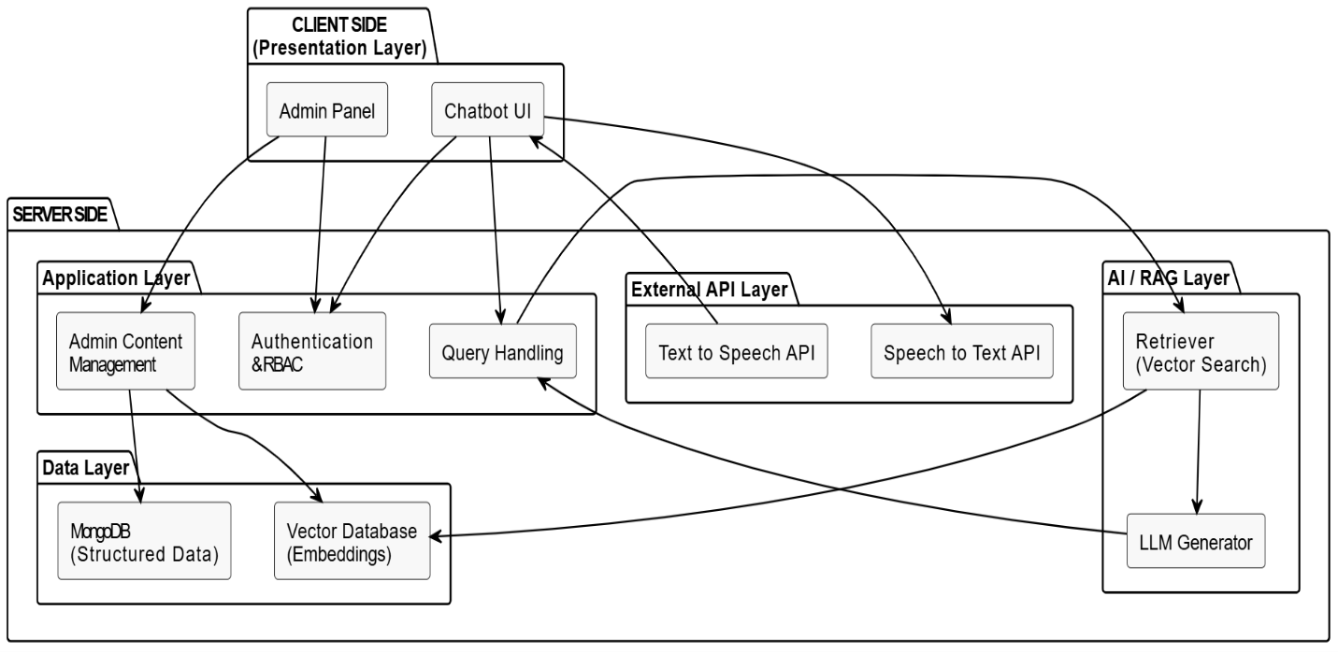
MongoDB

Fig 3.1 System Architecture

- Domain Modal
The SIBA Virtual Assistant domain model integrates user interaction, conversation management, and knowledge handling. Users, categorized as IBA-Associated and Non-IBA-Associated, initiate chat sessions and submit queries to the system. Administrators manage the centralized knowledge content, which is linked with vector embeddings to support efficient semantic search and intelligent response generation.
The model establishes a direct dependency where system Responses are produced from this verified Knowledge Content. This structure ensures that all answers are grounded in accurate university data (RAG architecture) while clearly distinguishing between internal and external user access.
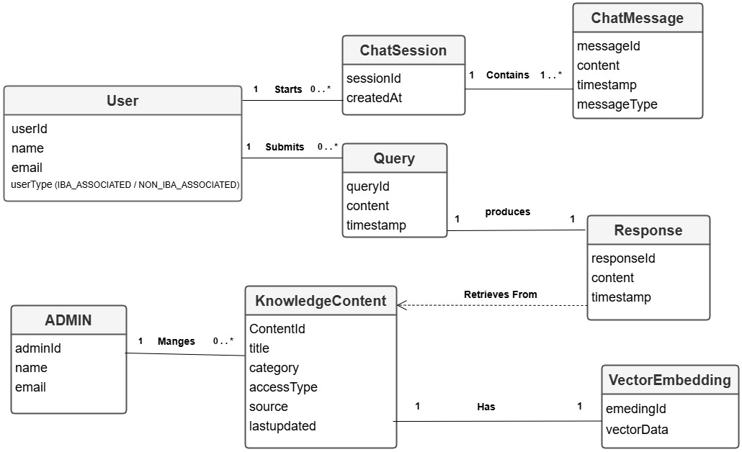

Fig 4.1 Domain Modal of System
- Class Diagram
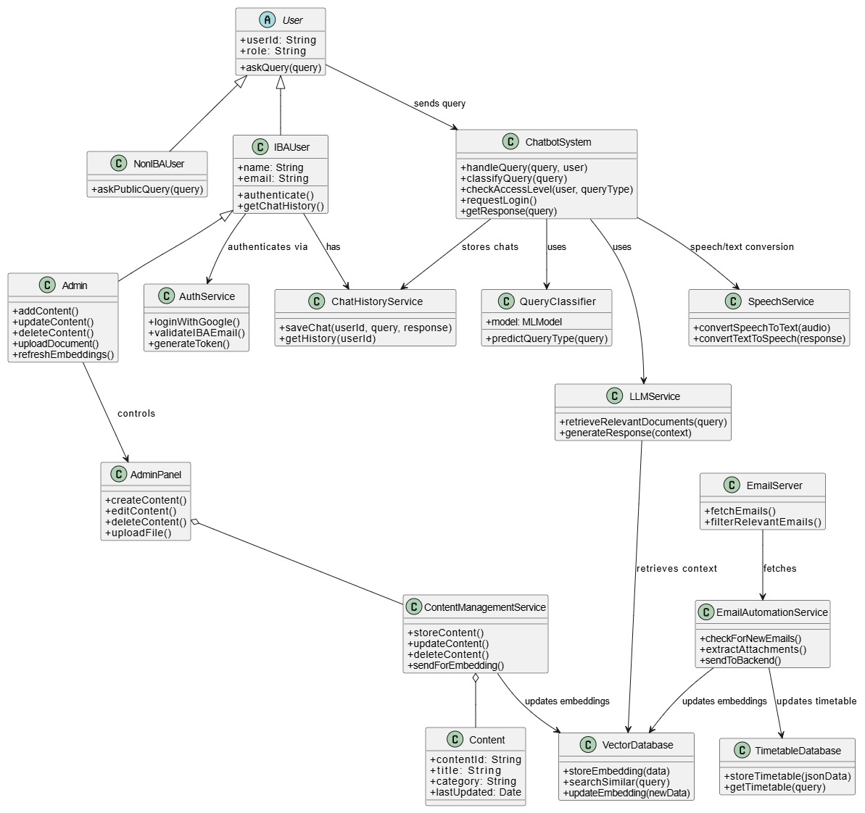
This diagram illustrates the high-level object-oriented structure, mapping relationships between actors (User, Admin) and core components like ChatbotSystem and LLMService. It details the specific classes and methods required to process text and voice queries using Retrieval-Augmented Generation (RAG). Furthermore, it defines the administrative components responsible for managing content and vector embeddings, providing a clear blueprint of the system’s static architecture.

Fig 5.1 Class Diagram of System
- Database Diagram
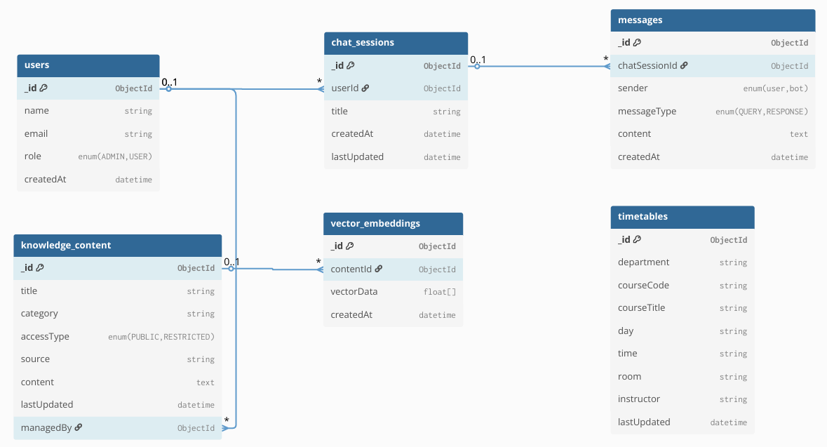
The database diagram presents the MongoDB-based data structure used by the AI-Powered SSVirtual Assistant for SIBA. It defines collections such as Users, Sessions, Chats, Messages, Knowledge Content, Embeddings, and Timetables, along with their attributes and relationships. The diagram shows how user interactions, chat histories, extracted email data, and vector embeddings are stored and linked to support authentication, conversation tracking, and semantic search. This structure ensures efficient data management, scalability, and seamless integration with AI-based retrieval mechanisms.

Fig 6.1 Database Diagram

- Entity Relationship Diagram (ERD)
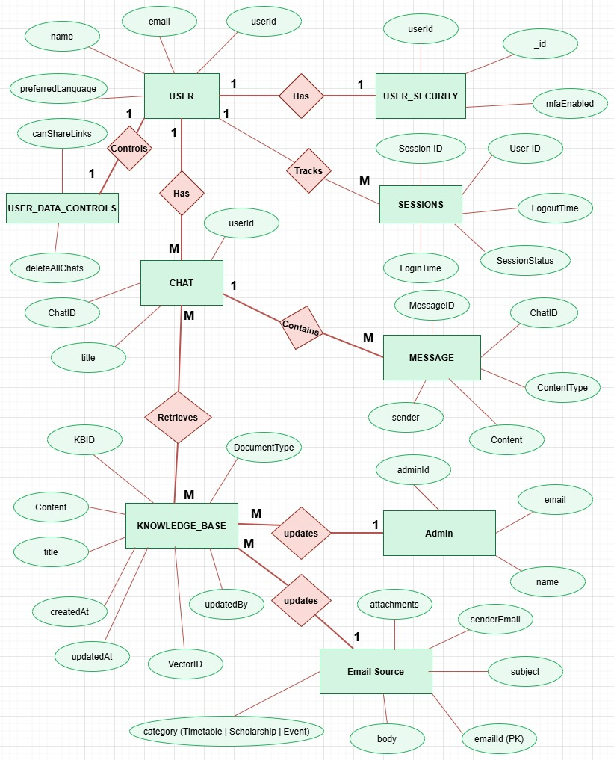
The Entity Relationship Diagram (ERD) illustrates the conceptual data model of the AI-Powered Virtual Assistant for SIBA by highlighting key entities and their relationships. It captures how Users interact with Chats and Messages, how sessions are tracked for security, and how knowledge sources such as Knowledge Base and Email Sources contribute information to the system. The ERD also shows the role of Admin in managing content and updates, ensuring accurate and up-to-date information. Overall, the ERD provides a clear conceptual understanding of data flow and relationships within the system.

Fig 7.1 Entity Relationship Diagram (ERD)

- Sequence Diagram
  - User Signup / Login via IBA Gmail Authentication
This diagram illustrates the secure login process for the application. The system uses Google OAuth to authenticate users but enforces a strict domain validation rule. Specifically, the Auth Service checks if the user's email address ends with @iba.edu.pk. If the domain is valid, the system checks the internal database to either log the user in or create a new account. This ensures the platform is restricted exclusively to authorized university personnel and students.
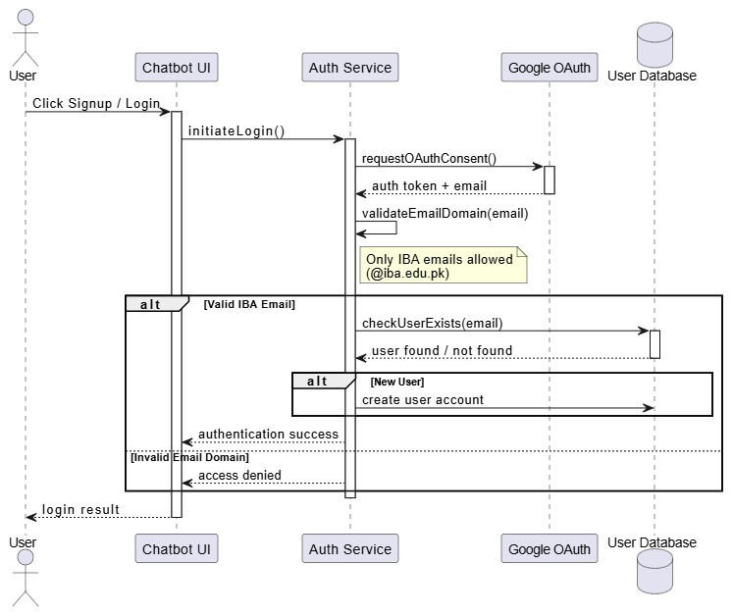

Fig 8.1: User Authentication Flow

  - General Query Processing
This diagram outlines the standard flow for answering general user questions. The system utilizes a Retrieval-Augmented Generation (RAG) approach. When a query is received, the system first searches the Vector Database for similar documents to gather relevant context. This context is then passed to the Large Language Model (LLM) Service, which generates a natural language response to be displayed to the user.
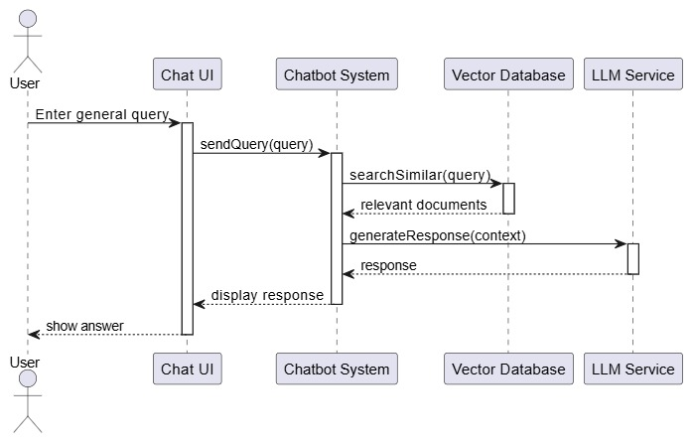

Fig 8.2: General Query Processing Flow

8.3 Create New Chat Session
This sequence demonstrates how a new conversation is established. When a user requests a new chat, the Chatbot System generates a unique session identifier and persists the session details in the Chat Database. This ID is returned to the UI, allowing the system to track conversation history and maintain context for subsequent interactions.

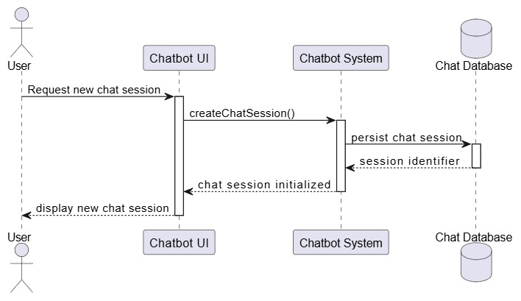

Fig 8.3: Chat Session Creation Flow

8.4 Ask Restricted Query
This flow highlights the security measures applied to sensitive or restricted academic data. Before processing a query, the Chatbot System calls the Auth Service to validate the user’s access rights (validateAccess). Only if access is granted does the system search the authorized knowledge base and generate a response. The conversation is then persisted in the database for audit and history purposes.

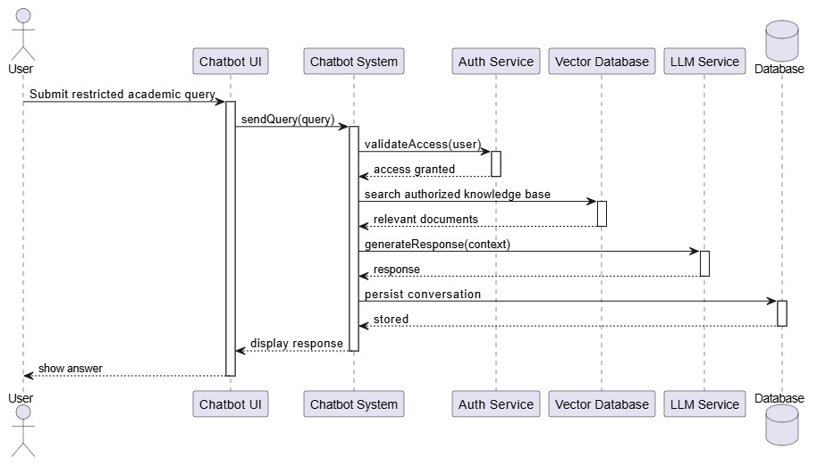
Fig 8.4: Restricted Query Handling Flow

8.5 Voice Mode Interaction
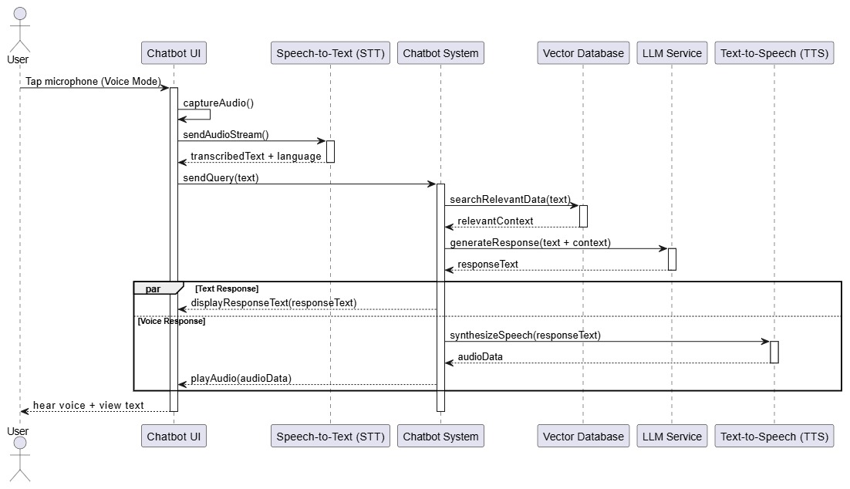
This diagram details the multimodal voice interaction feature. The process begins with the user tapping the microphone, capturing audio which is converted to text via a Speech-to-Text (STT) service. This text is processed similarly to a standard query. Once the LLM generates a text response, the system performs two parallel actions: it displays the text on the screen and simultaneously converts it into audio using a Text-to-Speech (TTS) service for the user to hear.

Fig 8.5: Voice Interaction Flow

8.6 Admin Content Management
This diagram shows the administrative workflow for managing the knowledge base. When an admin adds, updates, or deletes content via the Admin Panel, the system updates the primary MongoDB storage. Crucially, the system also automatically regenerates embeddings for the new content and updates the Vector Database. This synchronization ensures consistency between the raw data and the AI's search index.
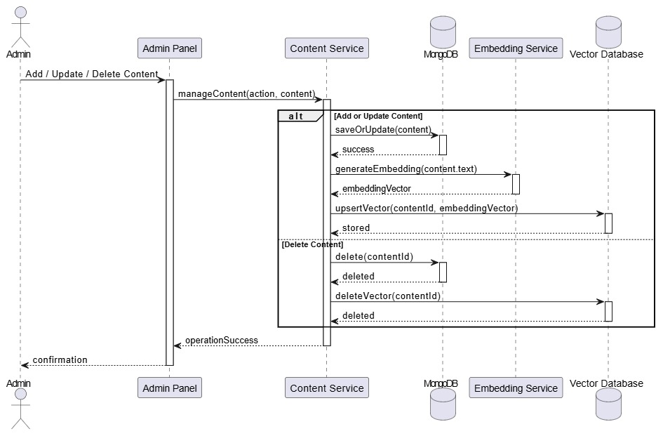

Fig 8.6: Admin Content Management Flow

8.7 Automated Email Ingestion And Information Extraction
This diagram depicts the background automation for keeping the system updated via email. When the Email Server receives a message, the Automation Service triggers a process to extract and classify the content (e.g., timetables, events, scholarships) using an LLM. The structured data is stored in MongoDB, and embeddings are generated and upserted into the Vector Database, ensuring the chatbot always has the latest institutional information.

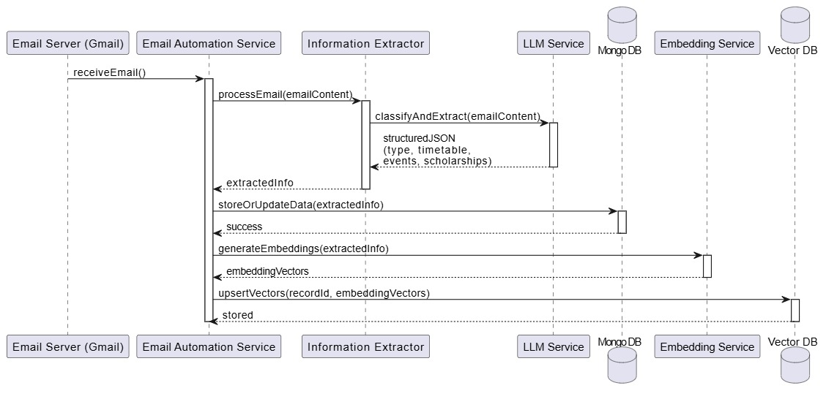

Fig 8.7: Automated Email Processing Flow

- System Interface Design
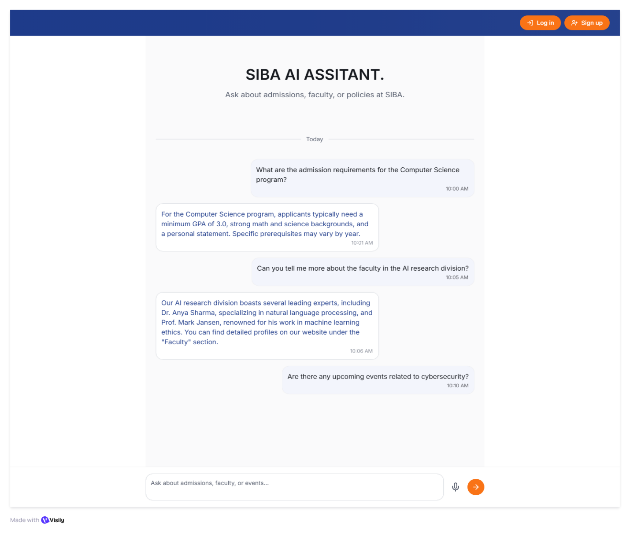
The System Interface Design describes how different users interact with the AI-Powered Virtual Assistant for SIBA through clear and role-based interfaces. It includes a Guest interface, where users can access basic information and view general content, and an authenticated user interface, where logged-in users can submit text or voice queries and receive intelligent responses from the chatbot. The Admin Panel interface is a separate, secure interface used only for content management, such as adding, updating, or deleting knowledge base content. Overall, this design ensures smooth interaction between users, administrators, and the backend AI system, while maintaining security, usability, and a consistent user experience.

Fig 9.1 Guest Mode Interface
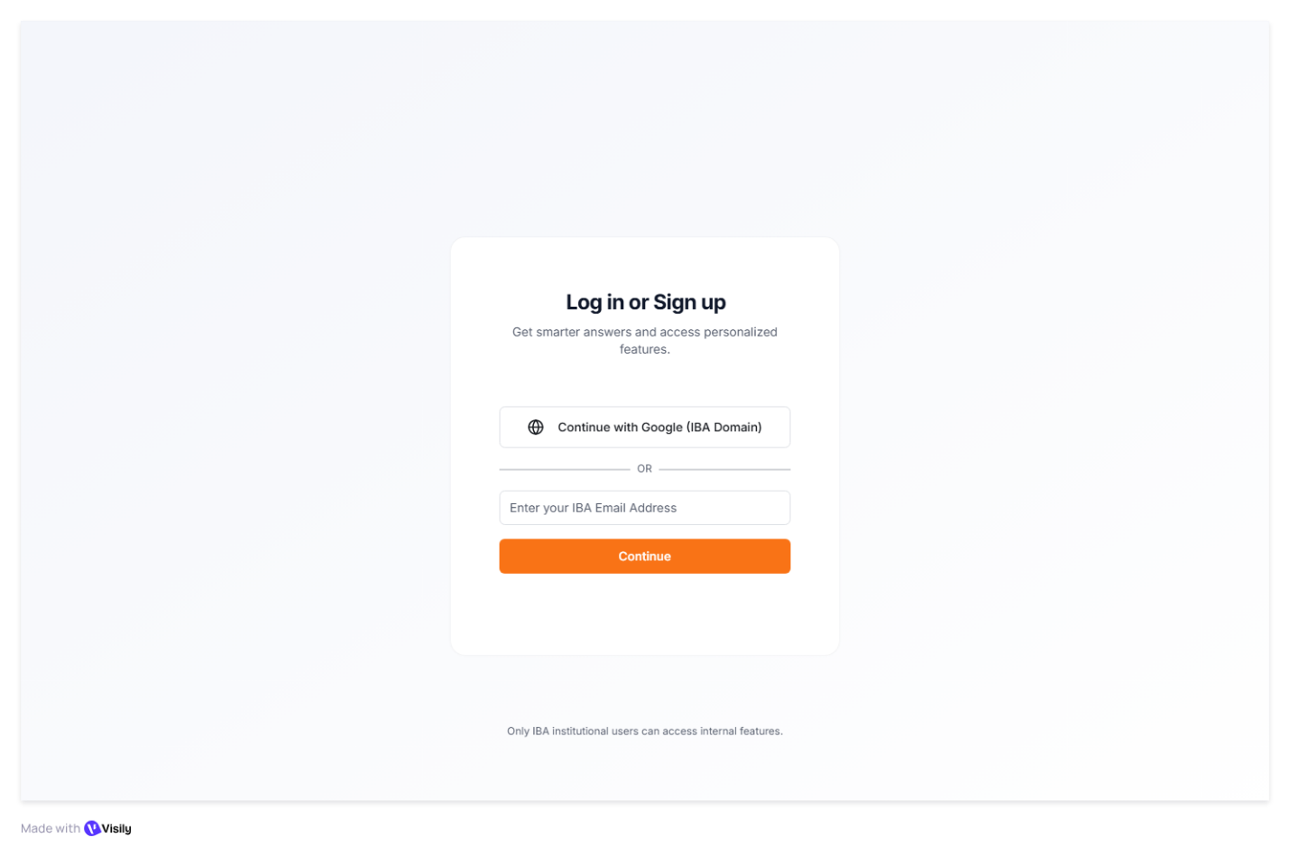
Fig 9.2 Login Interface

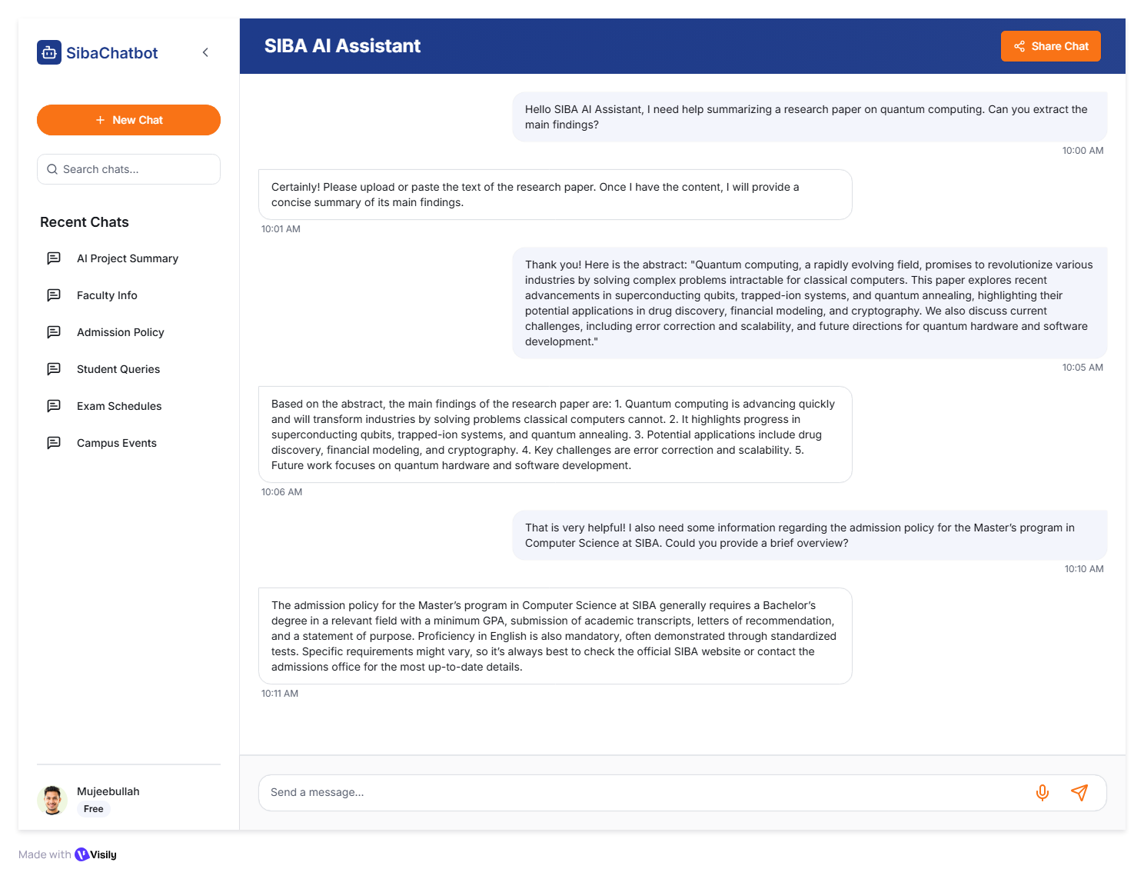 Fig 9.3 Authenticate User Interface

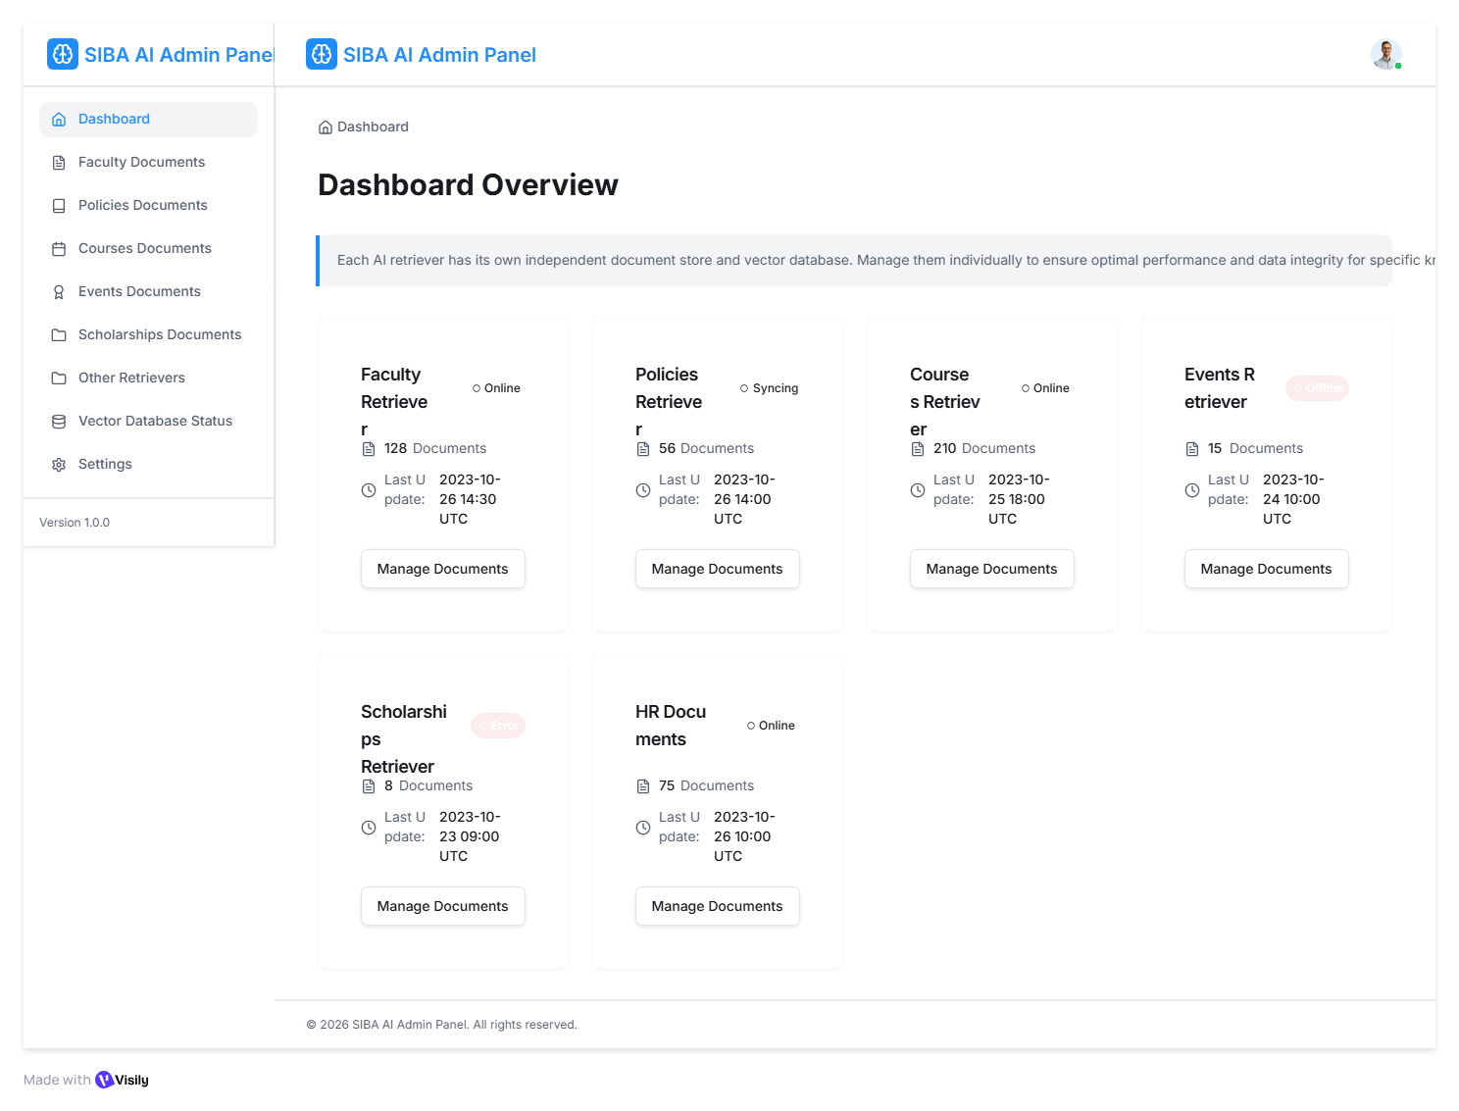

Fig 9.4 Admin Dashboard Interface

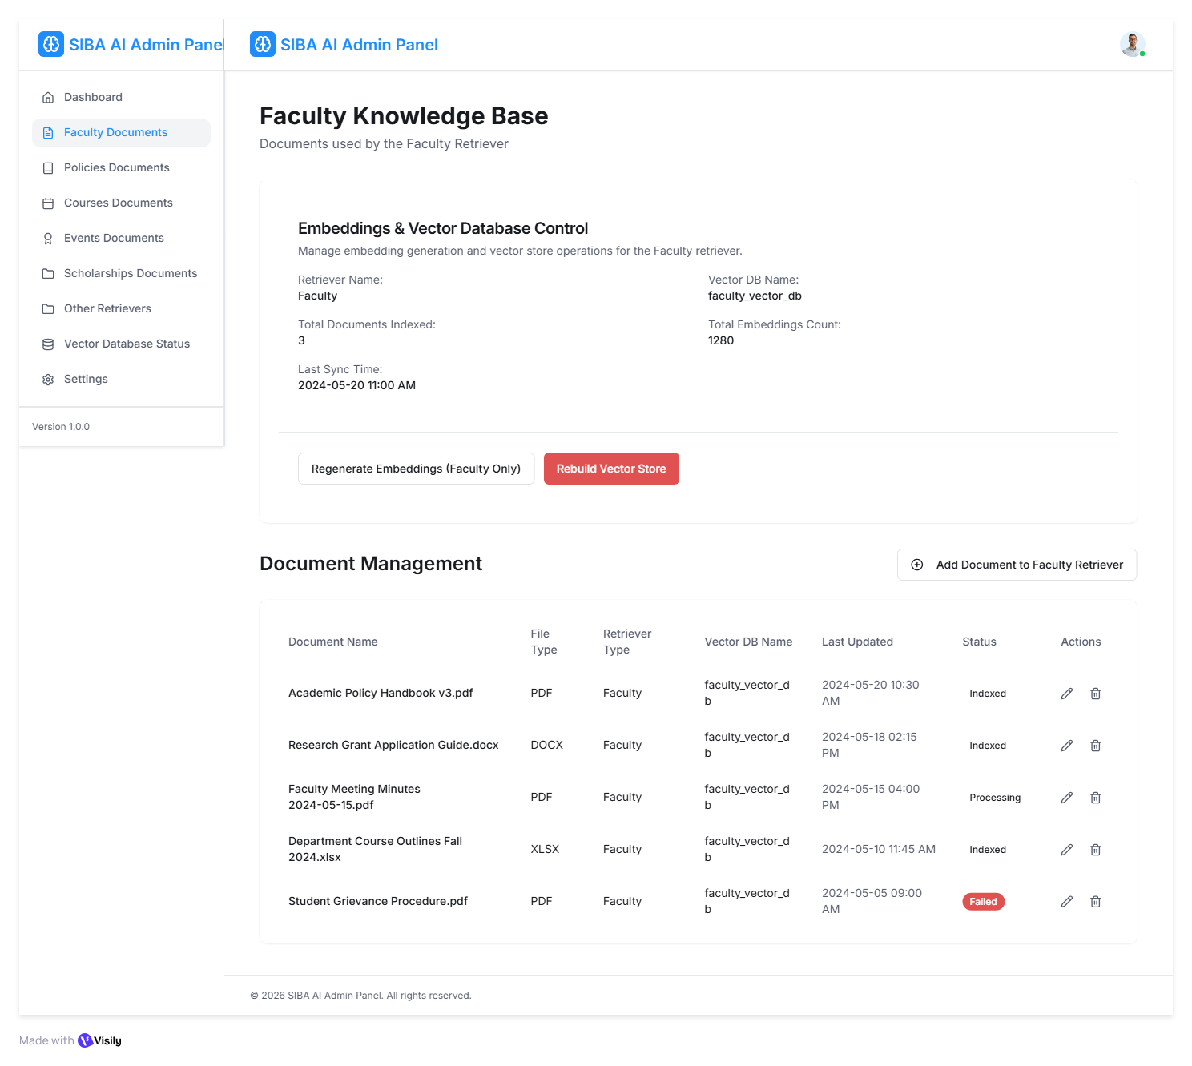

Fig 9.5 Retriever Document Management

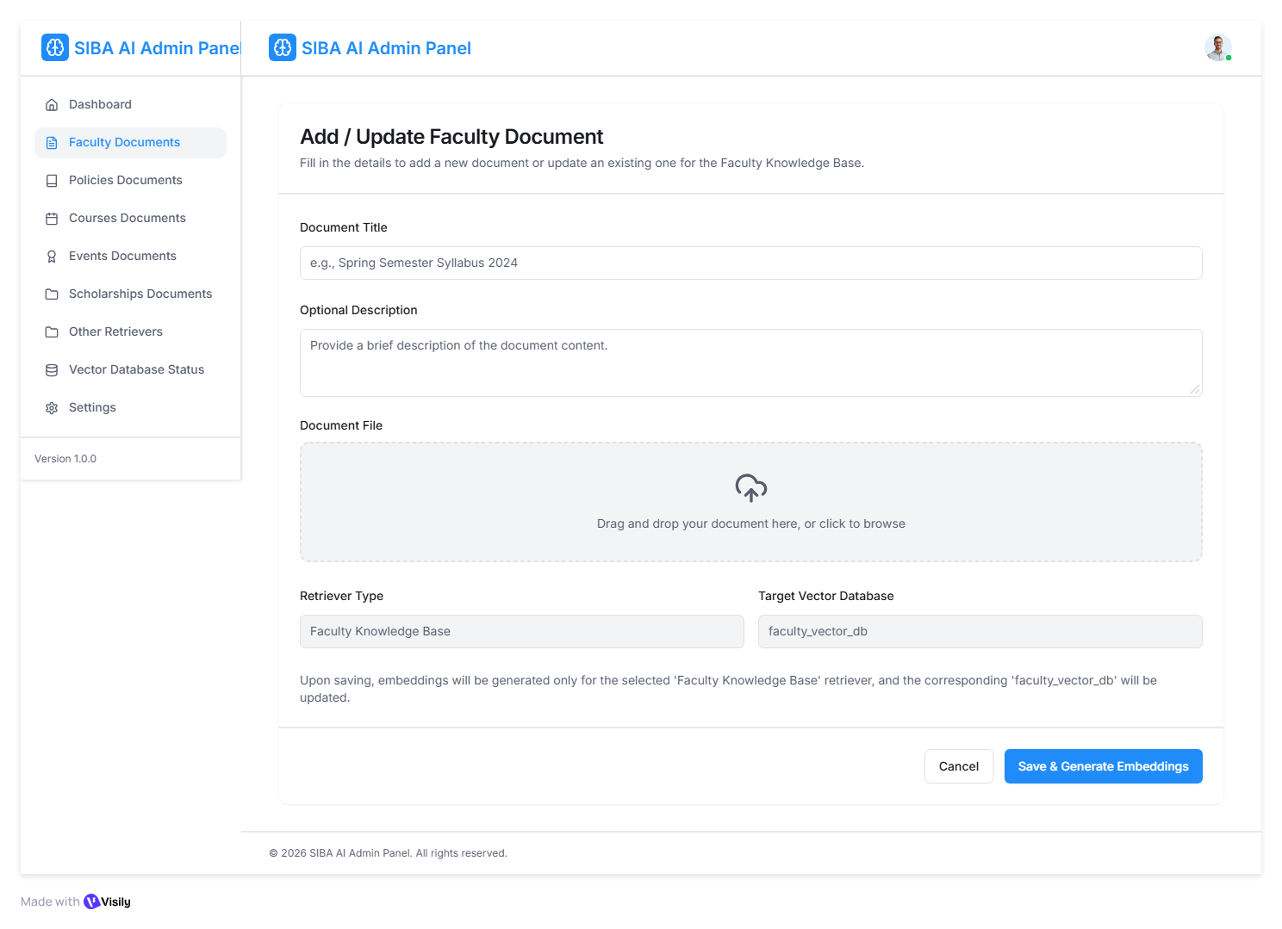

Fig 9.6 Add and Update Document nterface

- Test Cases
10.1 Authentication
Test Case ID | Feature | Description | Steps | Expected Result | Status
TC01 | Login (IBA user) | Login with valid IBA email | Enter valid iba-suk.edu.pk email & password | Login success → access full features | Pending
TC02 | Login (non-IBA user) | Login with non-IBA email | Enter Gmail/Yahoo email | Access denied → message 'Login allowed for IBA users only' | Pending
TC03 | Signup (IBA domain) | Create account using IBA email | Enter valid IBA email | Account created successfully | Pending
TC04 | Logout | Logout from IBA account | Click logout | Redirect to home page, public access enabled | Pending

Chatbot Basic Interaction
Test Case ID | Feature | Description | Steps | Expected Result | Status
TC06 | Unknown Query | Ask random topic | Ask 'Who is Messi?' | Bot replies to fallback message | Pending
TC07 | Context | Follow-up question | Ask 'Who is VC?' then 'What’s his qualification?' | Chatbot remembers context | Pending

Public Information (No Login Required)
Test Case ID | Feature | Description | Steps | Expected Result | Status
TC-08 | Grading Policy | Ask 'What is grading policy?' | Query grading | Displays grading scale | Pending
TC-09 | Attendance Policy | Ask 'Attendance rules?' | Query attendance | Shows 75% requirement | Pending
TC-10 | Course Schema | Ask 'Course schema BSCS' | Query schema | Displays of all subjects | Pending
TC-11 | Departments | Ask 'Departments in IBA' | Query departments | Lists of all departments | Pending

Test Case ID | Feature | Description | Steps | Expected Result | Status
TC-12 | Faculty Info | Ask 'CS Faculty list' | Logged in with IBA email | Displays all faculty names/designations | Pending
TC-13 | Timetable | Ask 'Timetable for BSCS 7th' | Logged in IBA user | Shows timetable | Pending
TC-14 | Faculty Schedule | Ask for 'Schedule of Dr. Ali' | Logged in IBA user | Shows class timings | Pending
TC-15 | Non-IBA restricted data | Ask private info without login | Public user asks 'Teacher schedule' | Reply: 'Login with IBA email required for this info' | Pending

Event Email Extraction Automation
Test Case ID | Feature | Description | Steps | Expected Result | Status
TC-16 | Email Extraction | Receive event email | Email from admin@iba-suk.edu.pk | System extracts title/date and saves | Pending
TC-17 | Duplicate Event | Same email again | Resend email | System ignores duplicate | Pending
TC-18 | Display Event | Ask 'Upcoming events' | Logged in IBA user | Shows latest events | Pending

System Functionality
Test Case ID | Feature | Description | Steps | Expected Result | Status
TC-19 | FastAPI Connection | Backend server test | Start chatbot | Connects successfully | Pending
TC-20 | MongoDB Connection | Database test | Startup | DB connected successfully | Pending
TC-21 | Knowledge Base Management | Admin updates chatbot knowledge base | 1. Login as Admin  2. Open Admin Panel  3. Update knowledge base content  4. Save changes | Chatbot knowledge base is updated successfully | Pending

Error & Exception Handling
Test Case ID | Feature | Description | Steps | Expected Result | Status
TC-22 | Network Error | Internet off | Ask question | 'Unable to Connect' message | Pending
TC-23 | Server Error | Backend off | Ask query | 'Server error. Try again later.' | Pending
TC-24 | Missing Data | Ask non-existent info | Ask 'Schedule for XYZ' | 'No info available' | Pending

